Python Assignment 1

**1. Write a Python program to print "Hello Python"?**

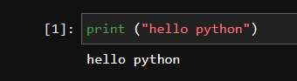

### 2. Write a Python program to do arithmetical operations addition and division.?

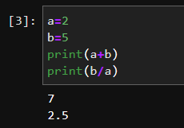

### 3. Write a Python program to find the area of a triangle?

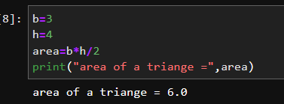

### 4. Write a Python program to swap two variables?[¶](https://brown-judge-anero.ineuron.app/lab/tree/work/Programming%20Assignment_1%20(2).ipynb#4.-Write-a-Python-program-to-swap-two-variables?)

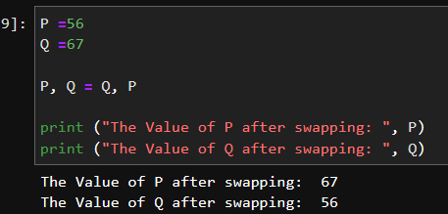

### 5. Write a Python program to generate a random number?[¶](https://brown-judge-anero.ineuron.app/lab/tree/work/Programming%20Assignment_1%20(2).ipynb#4.-Write-a-Python-program-to-swap-two-variables?)

